AI ASSSIGNMENT-13.4
NAME:PENNA BHARGAVI
BATCH:44
2303A52391
Task 1: Refactoring Data TransformationLogic
Scenario:
You are maintaining a data preprocessing script where numerical
transformations are written using verbose loops.
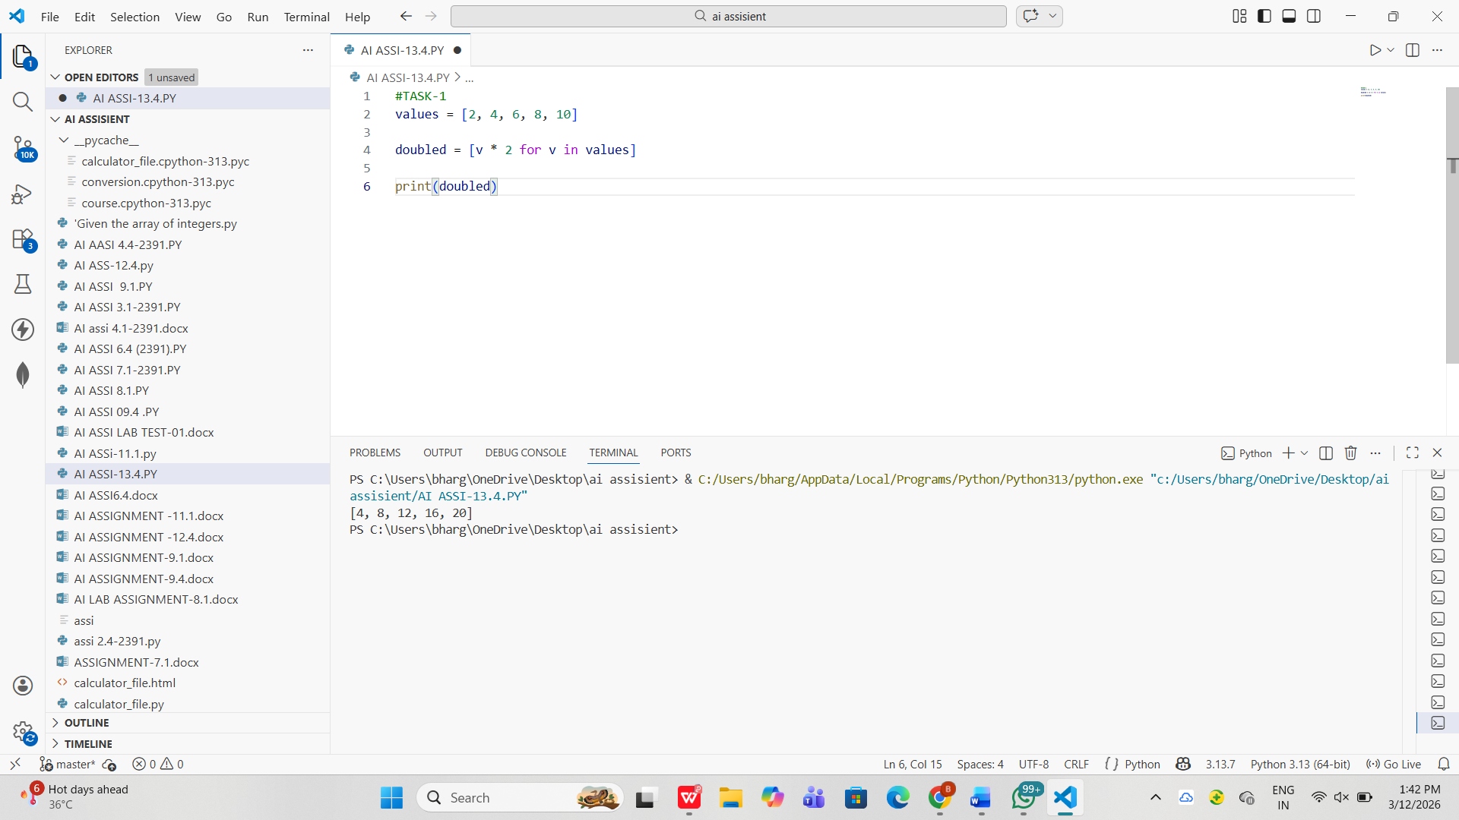
Observations:
- The legacy code uses an explicit loop to iterate through each element.
- Values are transformed by multiplying each number by 2.
- A new list is created using the append() method.
- The code works correctly but is longer and less Pythonic.
Task 2: Improving Text Processing CodeReadability
Scenario:
You are working on a log message generator that builds messages word
by word
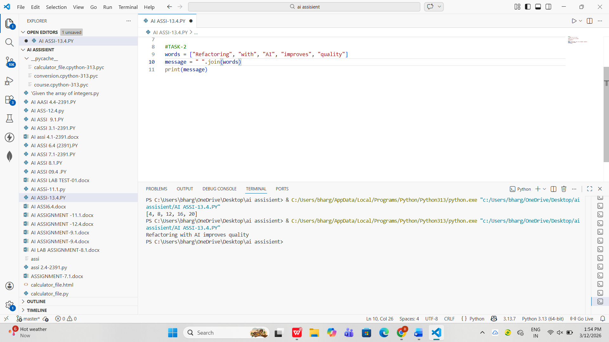
Observations:
- The legacy code builds a sentence using repeated string concatenation (+=).
- Repeated concatenation inside loops is less efficient in Python.
- The code also requires strip() to remove the extra space at the end.
- Using join() method is a more efficient approach
Task 3: Safer Access to Configuration Data
Scenario:
You are maintaining a configuration loader where dictionary keys may
or may not exist depending on deployment settings.

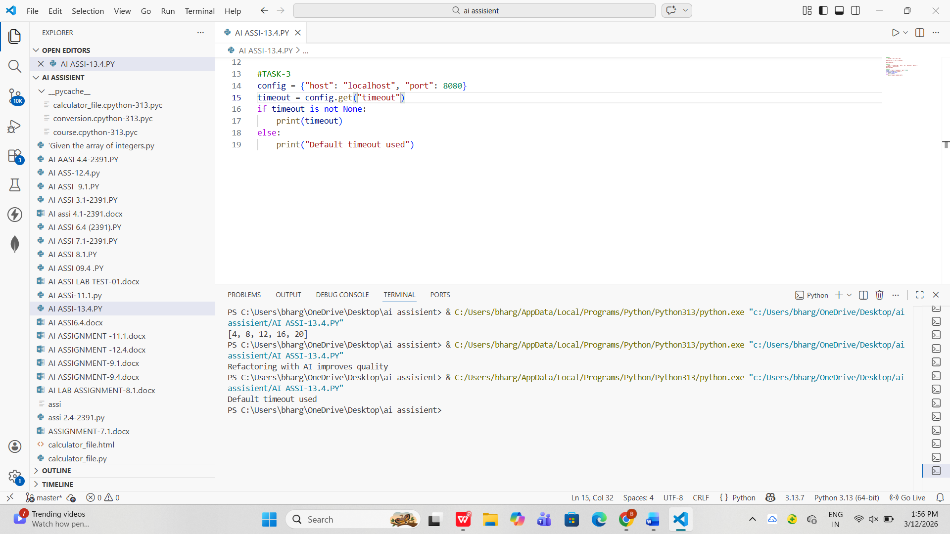
Observations:
- The legacy code checks dictionary keys using if key in dictionary.
- This approach requires extra conditional logic.
- Accessing missing keys directly can cause a KeyError.
- The get() method provides safer access to dictionary values.

Task 4: Refactoring Conditional Logic forScalability
Scenario:
You are enhancing a utility module that performs different operations
based on user input.

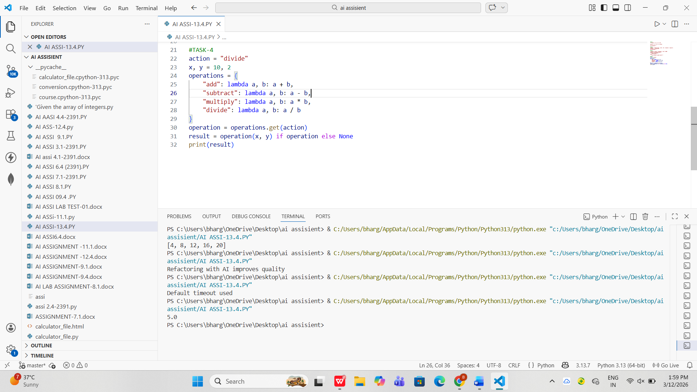
Observations:
- The legacy code uses multiple if–elif conditions to perform operations.
- As the number of operations increases, the code becomes long and difficult to maintain.
- A dictionary mapping technique can replace multiple conditions.
- Each operation is mapped to a function or lambda expression.

Task 5: Simplifying Search Logic inCollections
Scenario:
You are reviewing legacy inventory-check code that uses manual loops
to find elements.
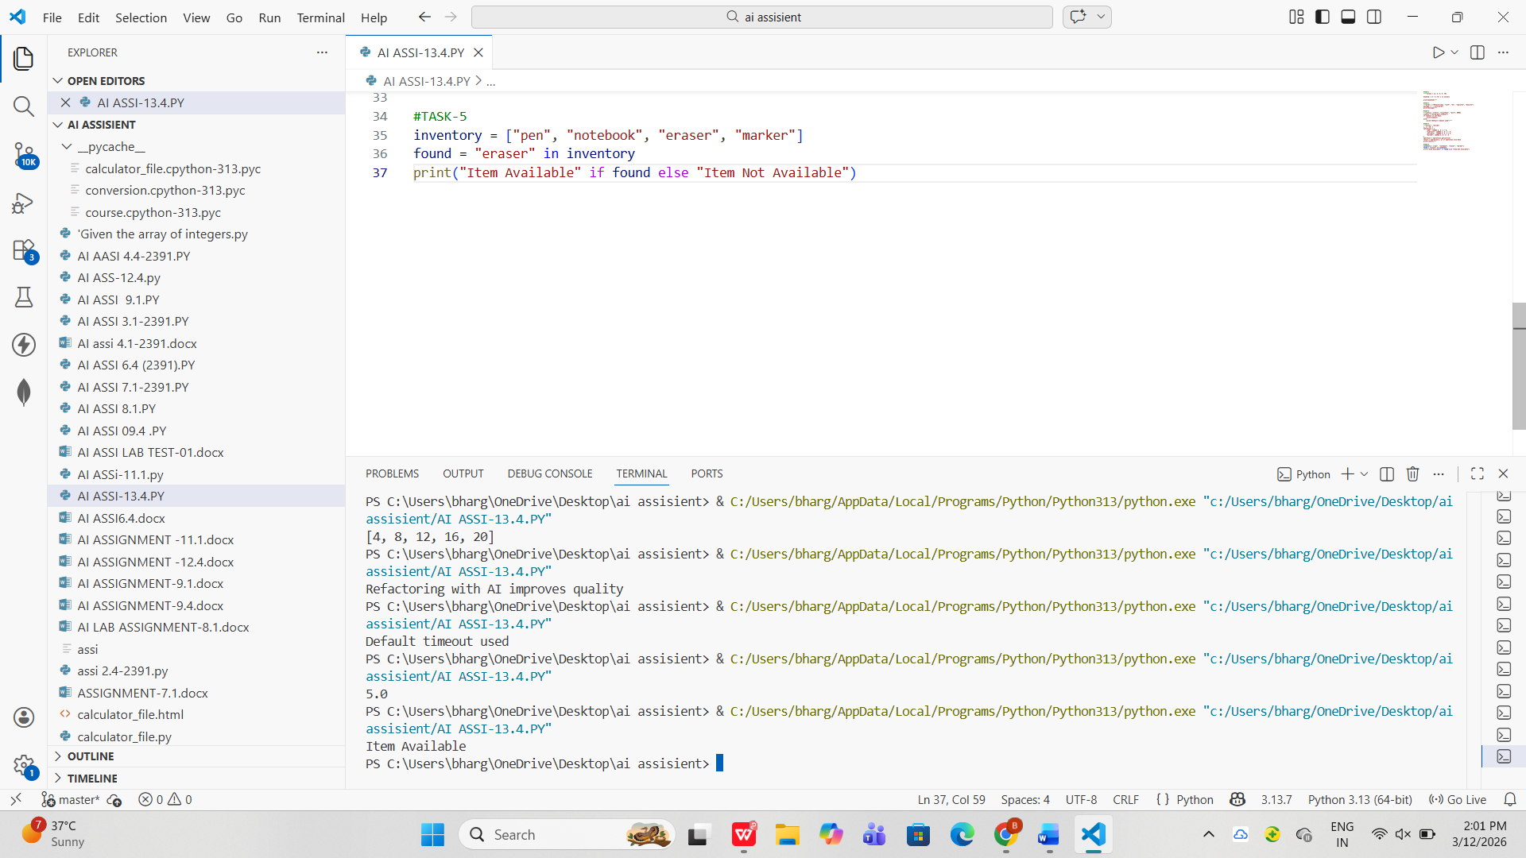
Observations:
- The legacy code searches for an item using a manual loop.
- A flag variable (found) is used to track whether the item exists.
- The loop uses break once the item is found.
- Python provides the in operator for membership testing.

